**For my machine learning I used the health data that was download from Kaggel.**

**The data was cleaned by a team member.**

I then imported and explored the data. From the data I found out that data is not balanced.**

**Next I converted the categorical data to numeric using pd.get.dummies.**

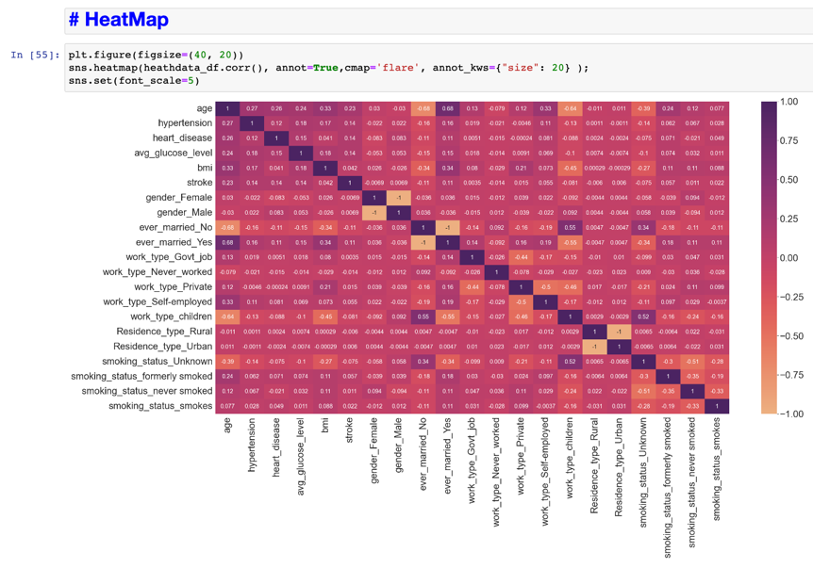

In this model random forest classifier was used, and forest classifier with features selection, from this the results showed that the data was over fitting.

The data was then over sampled using the SMOTE however it produces an unbalanced confusion matrix.

Then gridsearchCV was used but still gave an unbalanced confusion matrix.

Then the data was undersampling using RandomUnderSampler which produce a better/ balanced confusion matrix.